Project Report

2ND YEAR 2ND SEMESTER

Submitted To

|  |  |  |
| --- | --- | --- |
|  |  |  |
| **Amina Khatun.**  Lecturer  Dept. of Computer Science and Engineering  Jahangirnagar University  Savar, Dhaka. |  |  |
|  |  |  |

Group Members

|  |  |  |
| --- | --- | --- |
|  |  |  |
| **Name: Badhan Chandra Das**  Roll No: 51  Exam Roll: 140162 |  | **Name: Md. Ariful Islam**  Class Roll : 29  Exam Roll: 140140 |
|  |  |  |

Date of Submission : 16-11-2016

Contents

Project Title 1

Objectives 1

Materials 1

Program 1

Results 16

Discussoin 18

**Project Title** : Emoticons

**Objectives :**   
 The main objective of our project is to show the emoticons which we usually use in our social networking sites like as facebook , twitter , whatsapp , instagram etc .

**Materials:**

1. Codeblocks IDE
2. Graphics Files.

**Program :**

#include<bits/stdc++.h>

#include <graphics.h>

#include <conio.h>

using namespace std;

void drawEllipse_smaile(int xc, int yc, int x, int y)

{

putpixel(xc+x, yc+y, BLACK);

putpixel(xc-x, yc+y, BLACK);

}

void ellipseMidpoint_smile(int xc, int yc, int rx, int ry)

{

int rxSq = rx * rx;

int rySq = ry * ry;

int x = 0, y = ry, p;

int px = 0, py = 2 * rxSq * y;

drawEllipse_smaile(xc, yc, x, y);

//Region 1

p = rySq - (rxSq * ry) + (0.25 * rxSq);

while (px < py)

{

x++;

px = px + 2 * rySq;

if (p < 0)

p = p + rySq + px;

else

{

y--;

py = py - 2 * rxSq;

p = p + rySq + px - py;

}

drawEllipse_smaile(xc, yc, x, y);

delay(10);

}

//Region 2

p = rySq*(x+0.5)*(x+0.5) + rxSq*(y-1)*(y-1) - rxSq*rySq;

while (y > 0)

{

y--;

py = py - 2 * rxSq;

if (p > 0)

p = p + rxSq - py;

else

{

x++;

px = px + 2 * rySq;

p = p + rxSq - py + px;

}

drawEllipse_smaile(xc, yc, x, y);

delay(10);

}

}

void drawEllipse_sad(int xc, int yc, int x, int y)

{

putpixel(xc-x, yc+y, BLACK);*/

putpixel(xc+x, yc-y, BLACK);

putpixel(xc-x, yc-y, BLACK);

}

void ellipseMidpoint_sad(int xc, int yc, int rx, int ry)

{

int rxSq = rx * rx;

int rySq = ry * ry;

int x = 0, y = ry, p;

int px = 0, py = 2 * rxSq * y;

drawEllipse_sad(xc, yc, x, y);

//Region 1

p = rySq - (rxSq * ry) + (0.25 * rxSq);

while (px < py)

{

x++;

px = px + 2 * rySq;

if (p < 0)

p = p + rySq + px;

else

{

y--;

py = py - 2 * rxSq;

p = p + rySq + px - py;

}

drawEllipse_sad(xc, yc, x, y);

delay(10);

}

//Region 2

p = rySq*(x+0.5)*(x+0.5) + rxSq*(y-1)*(y-1) - rxSq*rySq;

while (y > 0)

{

y--;

py = py - 2 * rxSq;

if (p > 0)

p = p + rxSq - py;

else

{

x++;

px = px + 2 * rySq;

p = p + rxSq - py + px;

}

drawEllipse_sad(xc, yc, x, y);

delay(10);

}

}

void smile()

{

int gdriver=DETECT,gmode;

initgraph(&gdriver,&gmode,"c:\\tc\\bgi");

for( int i=0; i<50; i=i++)

{

setcolor(WHITE);

settextstyle(10,0,7);

outtextxy(0+i,390,"SMILE");

delay(50);

setcolor(WHITE);

settextstyle(10,0,7);

outtextxy(0+i,390,"SMILE");

}

circle(600,380,300);

setfillstyle(SOLID_FILL,YELLOW);

floodfill(602,385,WHITE);

ellipse(455,300,0,360,30,50); //eye1

setfillstyle(SOLID_FILL,BLACK);

floodfill(456,299,WHITE);

ellipse(725,300,0,360,30,50); //eye2

setfillstyle(SOLID_FILL,BLACK);

floodfill(726,299,WHITE);

setcolor(BLACK);

ellipseMidpoint_smile(600,530,120,65);

ellipseMidpoint_smile(599,531,120,65);

ellipseMidpoint_smile(598,530,120,65);

ellipseMidpoint_smile(597,531,120,65);

ellipseMidpoint_smile(596,529,120,65);

ellipseMidpoint_smile(595,532,120,65);

ellipseMidpoint_smile(594,529,120,65);

ellipseMidpoint_smile(593,532,120,65);

closegraph();

}

void sad()

{

int gdriver=DETECT,gmode;

initgraph(&gdriver,&gmode,"c:\\tc\\bgi");

for( int i=0; i<50; i=i++)

{

setcolor(WHITE);

settextstyle(10,0,7);

outtextxy(0+i,390,"SAD");

delay(50);

setcolor(WHITE);

settextstyle(10,0,7);

outtextxy(0+i,390,"SAD");

}

circle(600,380,300);

setfillstyle(SOLID_FILL,YELLOW);

floodfill(602,385,WHITE);

ellipse(455,300,0,360,30,50); //eye1

setfillstyle(SOLID_FILL,BLACK);

floodfill(456,299,WHITE);

ellipse(725,300,0,360,30,50); //eye2

setfillstyle(SOLID_FILL,BLACK);

floodfill(726,299,WHITE);

setcolor(BLACK);

ellipseMidpoint_sad(600,530,120,65);

ellipseMidpoint_sad(599,531,120,65);

ellipseMidpoint_sad(598,530,120,65);

ellipseMidpoint_sad(597,531,120,65);

ellipseMidpoint_sad(596,529,120,65);

ellipseMidpoint_sad(595,532,120,65);

ellipseMidpoint_sad(594,529,120,65);

ellipseMidpoint_sad(593,532,120,65);

closegraph();

}

void angry()

{

int gdriver=DETECT,gmode;

initgraph(&gdriver,&gmode,"c:\\tc\\bgi");

for( int i=0; i<50; i=i++)

{

setcolor(WHITE);

settextstyle(10,0,7);

outtextxy(0+i,390,"ANGRY");

delay(50);

setcolor(WHITE);

settextstyle(10,0,7);

outtextxy(0+i,390,"ANGRY");

}

circle(600,380,300);

setfillstyle(SOLID_FILL,RED);

floodfill(602,385,WHITE);

ellipse(475,310,0,360,50,40); //eye1

setfillstyle(SOLID_FILL,BLACK);

floodfill(456,299,WHITE);

ellipse(695,310,0,360,50,40); //eye2

setfillstyle(SOLID_FILL,BLACK);

floodfill(726,299,WHITE);

setcolor(BLACK);

arc(600,530,0,180,100);

ellipse(600,530,0,180,100,45);

setcolor(BLACK);

ellipse(480,300,360,164,90,90); //upper //vuru1

ellipse(475,300,360,163,95,50); //lower

setfillstyle(SOLID_FILL,BLACK);

floodfill(477,301,BLACK);

ellipse(690,300,16,180,90,90); //upper //vuru2

ellipse(695,300,19,180,95,50); //lower

getch();

closegraph();

}

void cry()

{

int gdriver=DETECT,gmode;

initgraph(&gdriver,&gmode,"c:\\tc\\bgi");

for( int i=0; i<50; i=i++)

{

setcolor(WHITE);

settextstyle(10,0,7);

outtextxy(0+i,390,"CRY");

delay(50);

setcolor(WHITE);

settextstyle(10,0,7);

outtextxy(0+i,390,"CRY");

}

circle(600,380,300);

setfillstyle(SOLID_FILL,YELLOW);

floodfill(602,385,WHITE);

ellipse(455,300,0,360,40,50); //eye1

setfillstyle(SOLID_FILL,BLACK);

floodfill(456,299,WHITE);

for(int i=448; i<=468; i++)

{

line(i,345,i,635); //tear1

}

ellipse(725,300,0,360,40,50); //eye2

setfillstyle(SOLID_FILL,BLACK);

floodfill(726,299,WHITE);

for(int i=720; i<=740; i++)

{

line(i,345,i,645); //tear2

}

setcolor(BLACK);

arc(600,550,0,180,100); //mouth

ellipse(600,550,0,180,100,45);

getch();

closegraph();

}

void wow()

{

int gdriver=DETECT,gmode;

initgraph(&gdriver,&gmode,"c:\\tc\\bgi");

for( int i=0; i<50; i=i++)

{

setcolor(WHITE);

settextstyle(10,0,7);

outtextxy(0+i,390,"WOW..");

delay(50);

setcolor(WHITE);

settextstyle(10,0,7);

outtextxy(0+i,390,"WOW..");

}

circle(600,380,300);

setfillstyle(SOLID_FILL,YELLOW);

floodfill(602,385,WHITE);

ellipse(455,300,0,360,40,60); //eye1

setfillstyle(SOLID_FILL,BLACK);

floodfill(456,299,WHITE);

ellipse(725,300,0,360,40,60); //eye2

setfillstyle(SOLID_FILL,BLACK);

floodfill(726,299,WHITE);

ellipse(600,475,0,360,90,120);

setfillstyle(SOLID_FILL,BLACK);

floodfill(604,474,WHITE);

getch();

closegraph();

}

int main()

{

cout<<"\n ----------Here is our project for EMOTICONS.-------------\n\n";

cout<<"Choose your options.\n\n";

cout<<"Press 1 for Smile.\n";

cout<<"Press 2 for Sad.\n";

cout<<"Press 3 for Cry.\n";

cout<<"Press 4 for Wow.\n";

cout<<"Press 5 for Angry.\n\n";

int ch;

while(cin>>ch)

{

if(ch==1)

{

smile();

}

else if(ch==2)

{

sad();

}

else if (ch==3)

{

cry();

}

else if(ch==4)

{

wow();

}

else

{

angry();

}

}

return 0;

}

# Results

Here Is our Results:

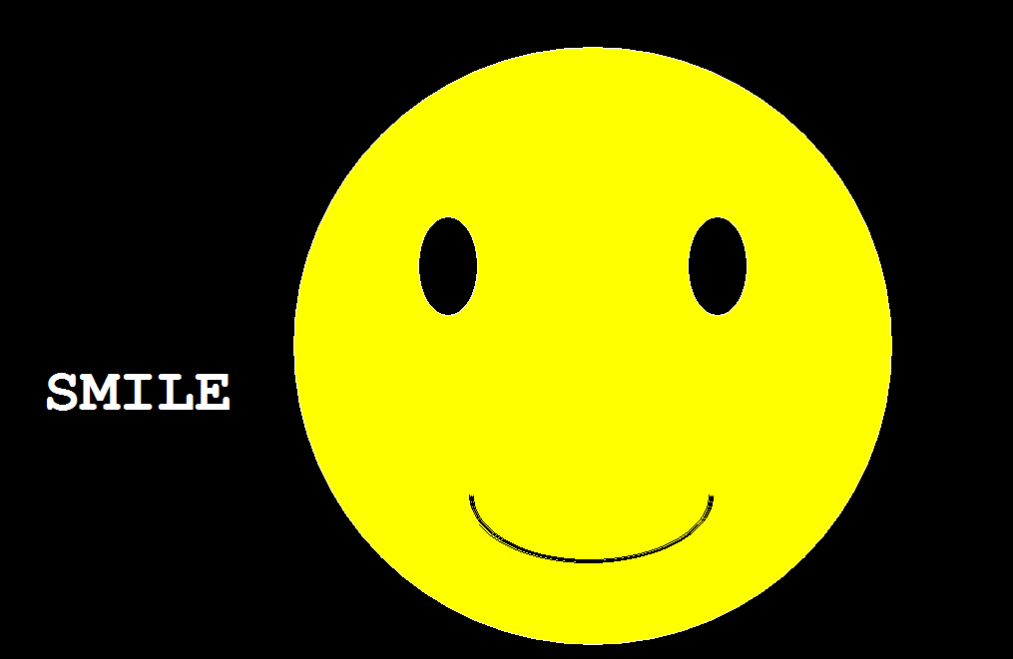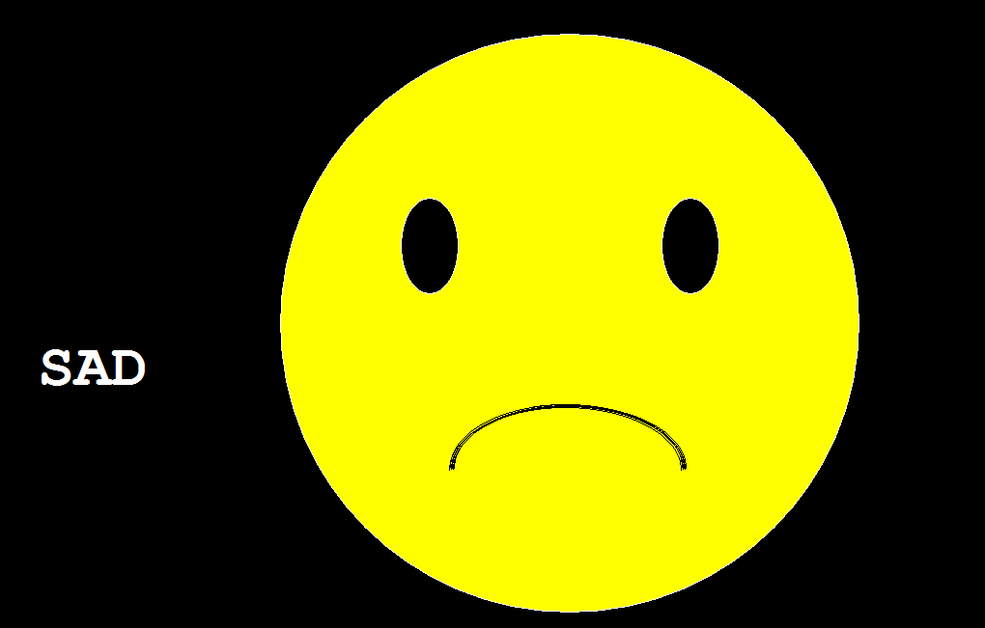

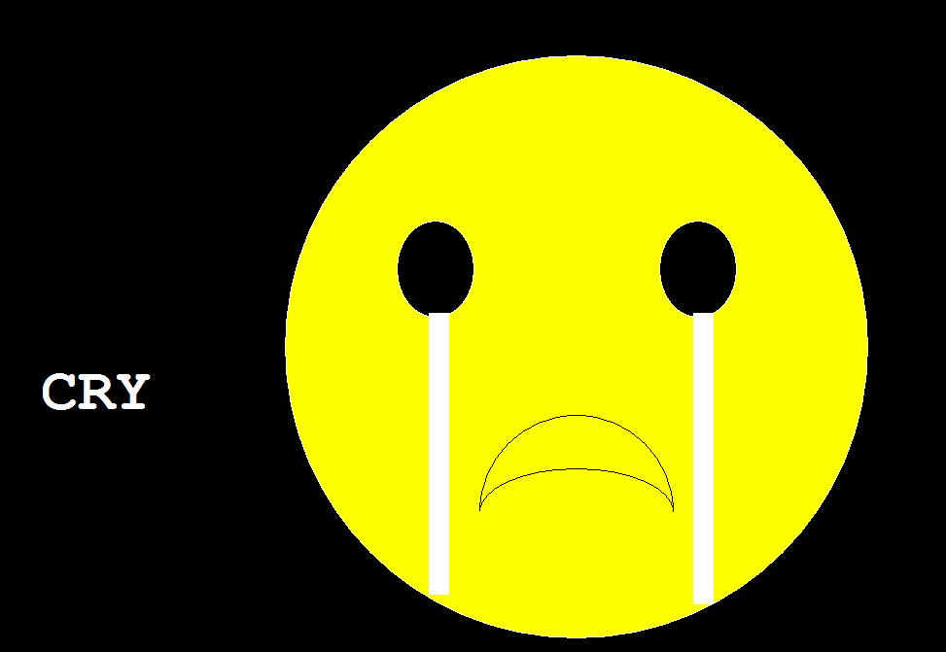

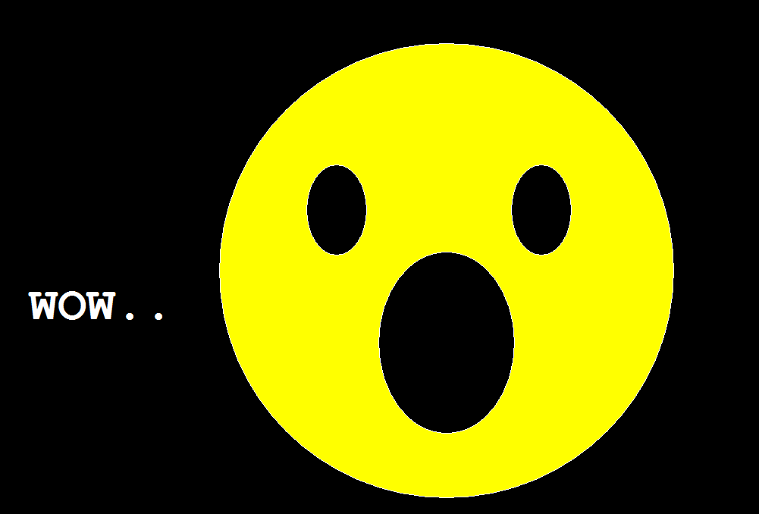

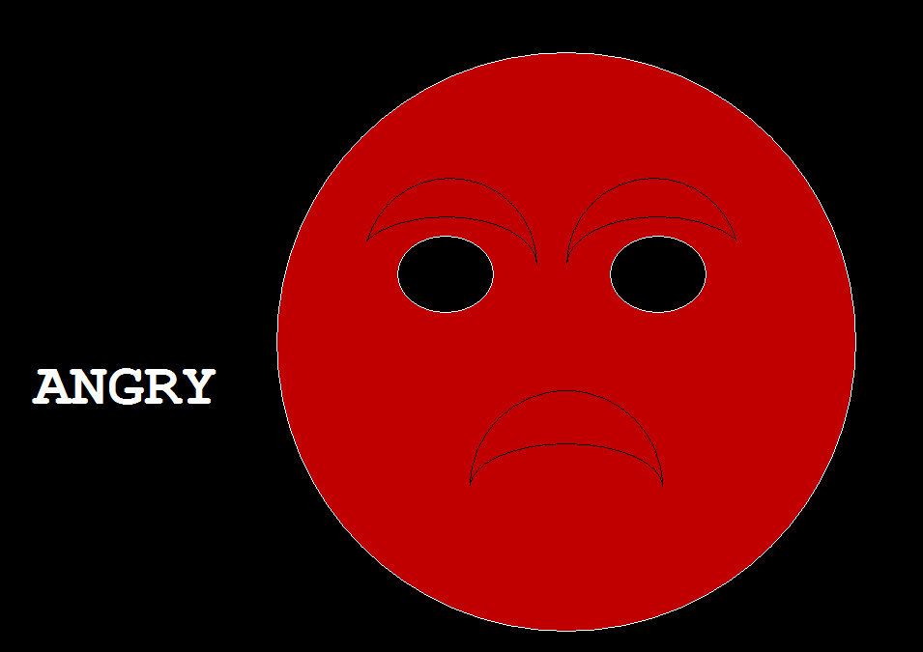

Discussion:

So here is our project emoticons. We have made it very simply with the graphics properties like as circle , ellipse, arcs, graphics animations etc. There were some obstracles we faced to make this projects whichs we have solved with the help of internet and differt types of sites.